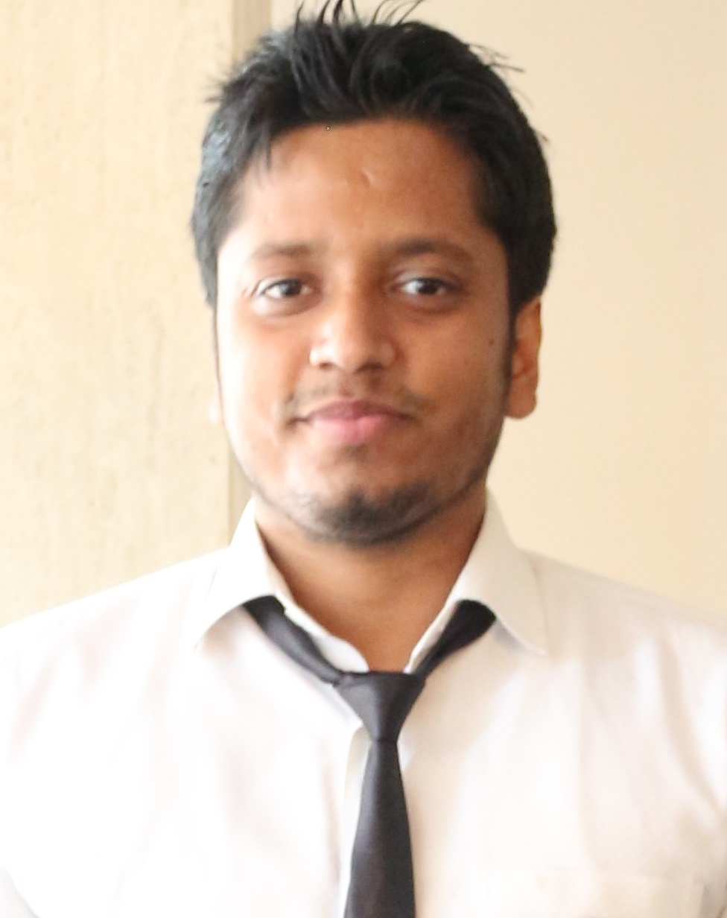

**Akshay Kumar**

Recently graduated from Malaviya National Institute of Technology Jaipur – Bachelor of Technology in **Electrical Engineering**

**Contribution**: Mechanism Design & Fabrication, Motion Realisation & Socket Programming

**Current Position**: Pursuing Master of Science(MS) in Robotics Engineering from Worcester Polytechnic Institute, MA, USA

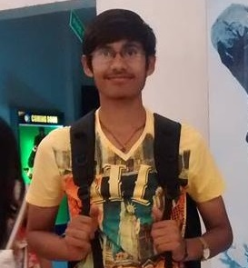

**Jatin Verma**

Recently graduated from Malaviya National Institute of Technology Jaipur – Bachelor of Technology in **Electrical Engineering**

**Contribution**: Object Detection and Recognition, Face Recognition & Facial Expression Recognition

**Current Position**: Pursuing Master of Engineering(M Eng.) in Electrical Engineering with specialization in Power Systems from Nanyang Technological University, Singapore

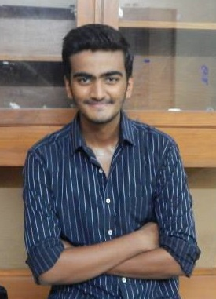

**Shubham Tripathi**

Recently graduated from Malaviya National Institute of Technology Jaipur – Bachelor of Technology in **Electrical Engineering**

**Contribution**: Speech-based Question-Answering System Development & Socket Programming

**Current Position**: Pursuing Master’s in Biotechnology Innovation and Computation (MSBIC) from Carnegie Mellon University, Pittsburgh, USA

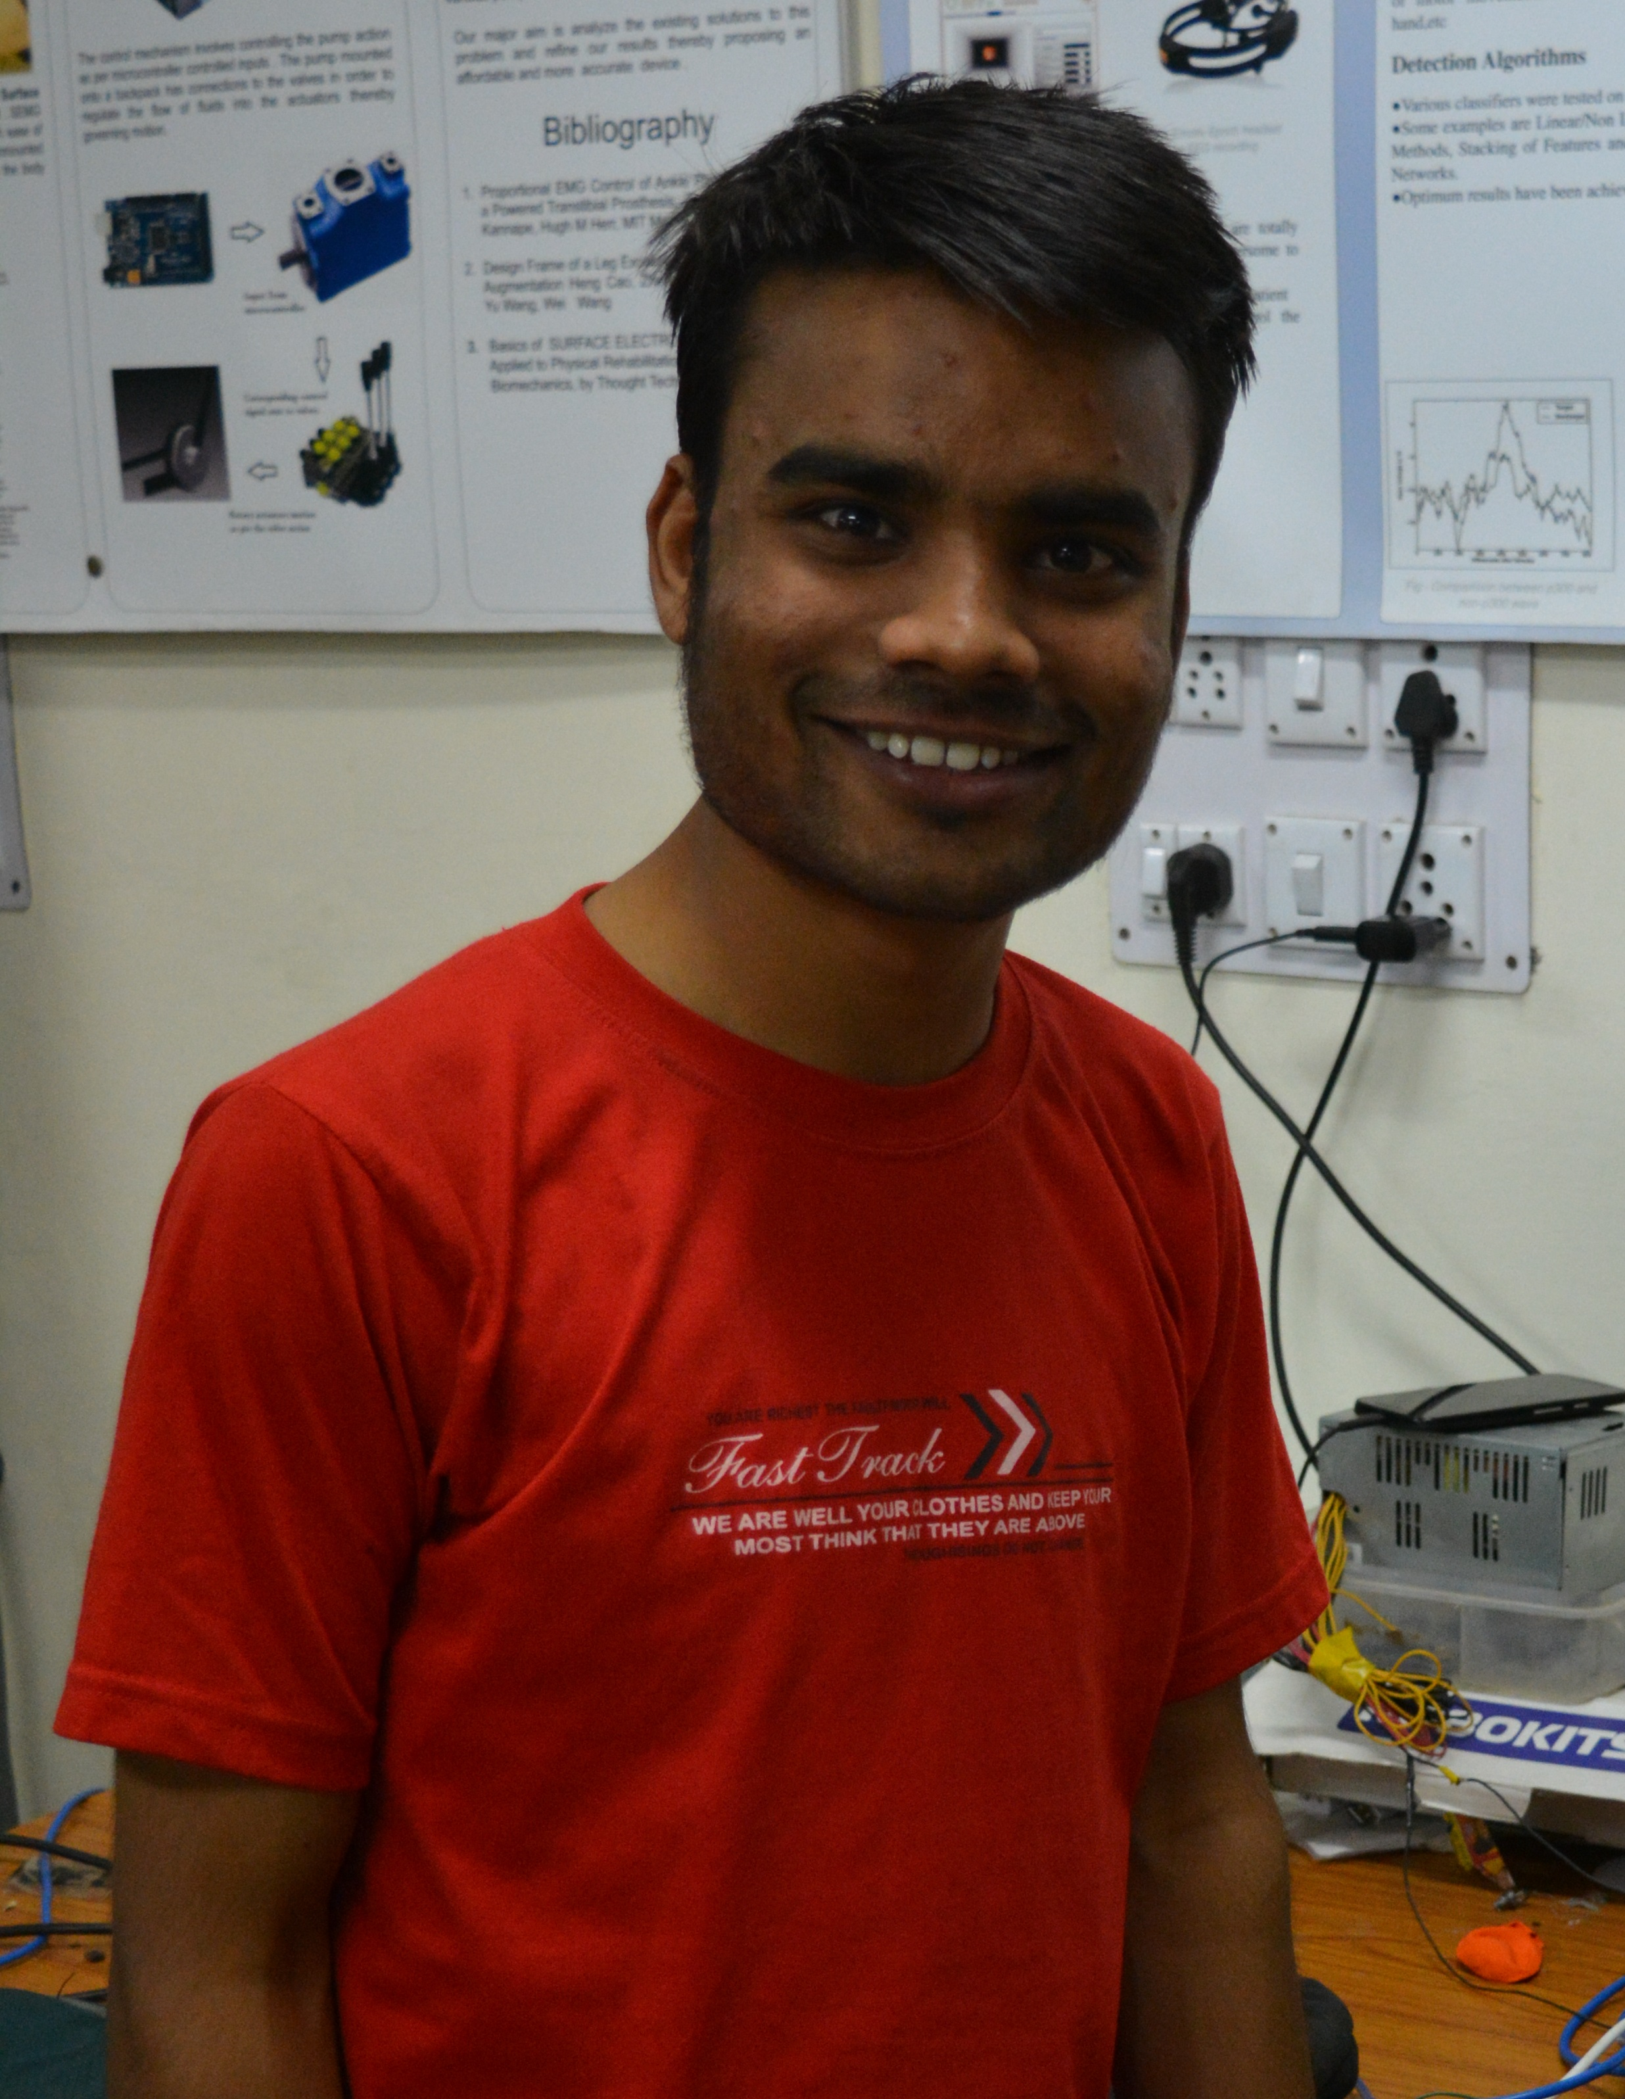

**Hemant Singh**

Recently graduated from Malaviya National Institute of Technology Jaipur – Bachelor of Technology in **Electrical Engineering**

**Contribution**: Object Detection and Recognition, Face Recognition & Facial Expression Recognition using ML Techniques

**Current Position**: Working as Software Management Expert at Nokia Pvt. Ltd. Noida, Uttar Pradesh. India

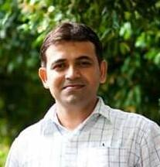

**Dr. Rajesh Kumar**

Dr. Rajesh Kumar is an Associate Professor in the Department of Electrical Engineering at Malaviya National Institute of Technology Jaipur. His role was instrumental in getting the project reach an apt level of efficiency and performance. He is also the mentor of ZINE, the college’s robotics and research group, of which – Shubham, Jatin and Akshay happen to be a part of.

His areas of interest include AI, robotics, algorithm design and optimization techniques among others.